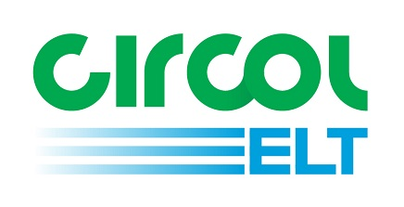

Guidance Document for Circol ELT

Login

eQF083 - Version 1.0
Date 01/10/2018

Contents
Introduction 3
New 4 Digit PIN 3
Password Reset - when logged in 5
Change Password: 5
Change PIN: 6
Password Reset - when locked out 7

Introduction
Welcome to Circol ELT’s reference guide to logging into the reporting portal. The aim of this document is to assist users to log in. If you have any questions that are not addressed within this document please get in touch with Circol ELT via the contact details below:
Circol ELT contact details:
P: (01) 4618 600
E: info@Circolelt.ie
W: www.Circolelt.ie

New 4 Digit PIN
Once the login page is displayed you will be asked to input your Username and Password. Remember, this password is case-sensitive. If you forget or misplace your password you can reset by clicking on Forgot Password or PIN? Click here. See page 7 for more details. You can also create a new Password and PIN see page 5.

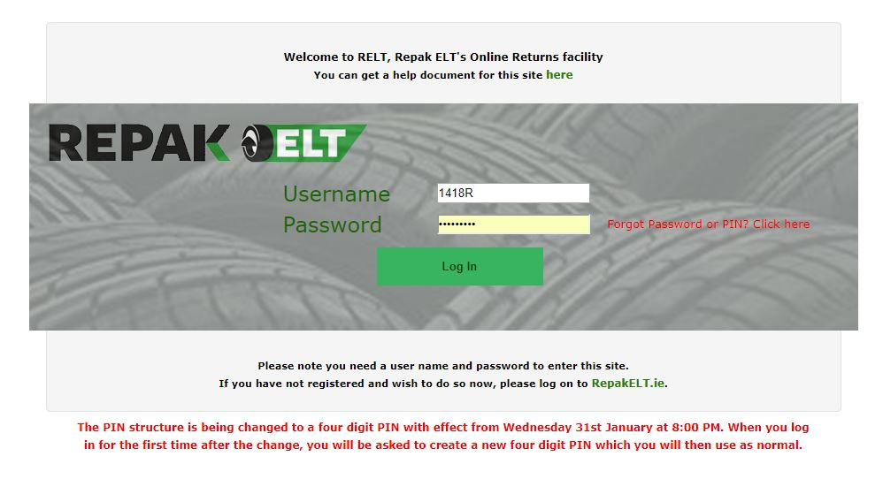

Once you have logged in, the following page will appear. Enter in a 4 digit PIN and click Continue. You will now be logged in to your member account.
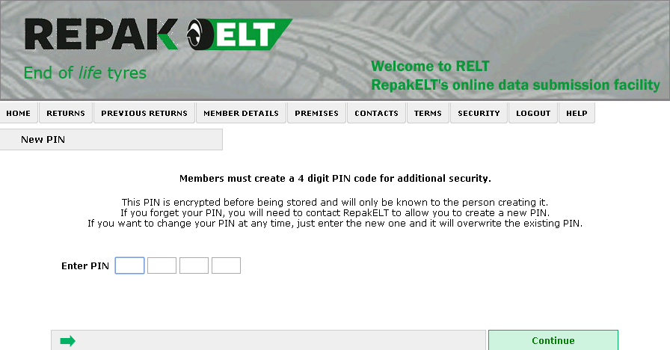

This PIN code is known only to the user so it is important to take note and keep it somewhere safe and accessible. Circol ELT have no record of your PIN. Should any difficulties arise and you cannot reset the PIN yourself we can reset it back to blank, so you will be asked to re-create a new PIN code the next time you attempt to log in.

On returning to your member account and after entering your Username and Password, the following page will appear (in place of the old PIN login page). Enter the selected digits from the four digit PIN you created and click Continue on the bottom right hand side of the page.
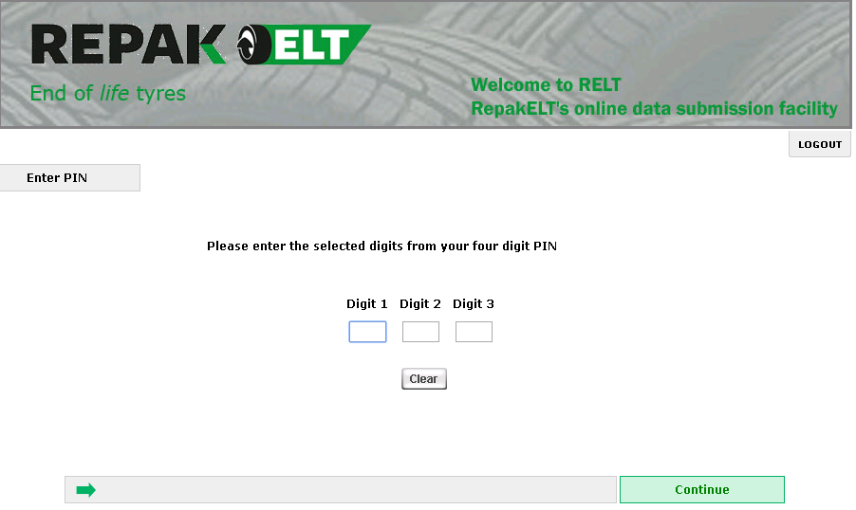

Password Reset - when logged in
Members can also change the Password and PIN when logged in.
Click on the Security tab on the grey toolbar, this will open the following page. Select GO for either Change Password or Change PIN.
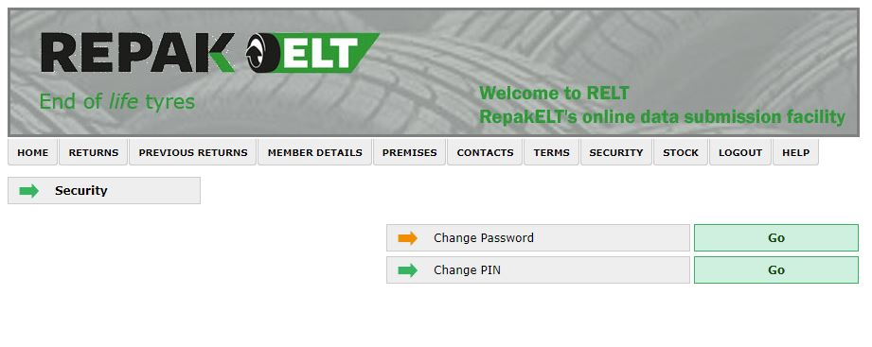

Change Password:
The new password is required to be a minimum of 6 characters in length. Enter the old password, the new password and then confirm the new password. Save on the bottom right hand side.
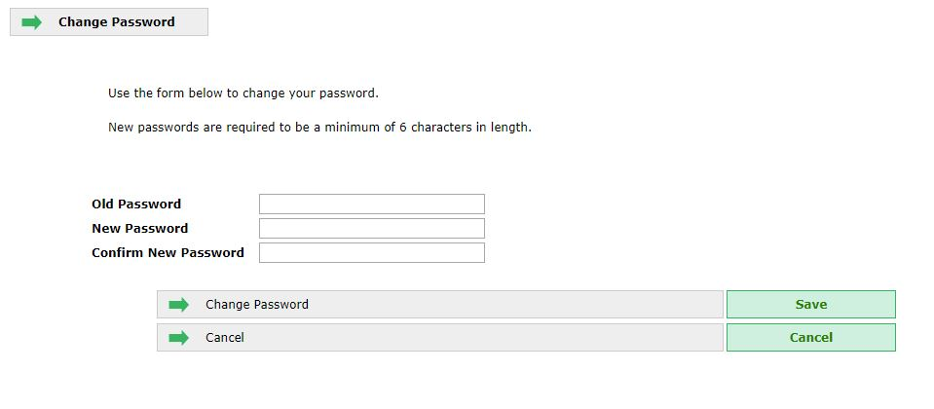

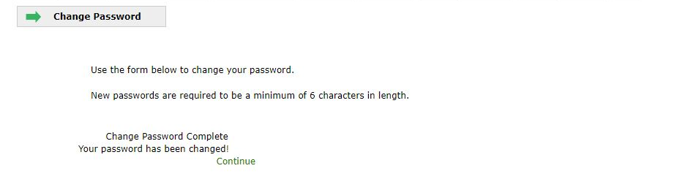
The following page will open, click Continue and you will be returned to the Security page. Your Password is now rest.

Change PIN:
Back on the Security page select GO, Change PIN. Enter in a 4 digit PIN and click Continue on the bottom right hand side of the page. You will then be returned to the Security page. Your PIN is now reset.

Password Reset - when locked out
If you forget or misplace your password you can reset on the login page by clicking on Forgot Password or PIN? Click here.
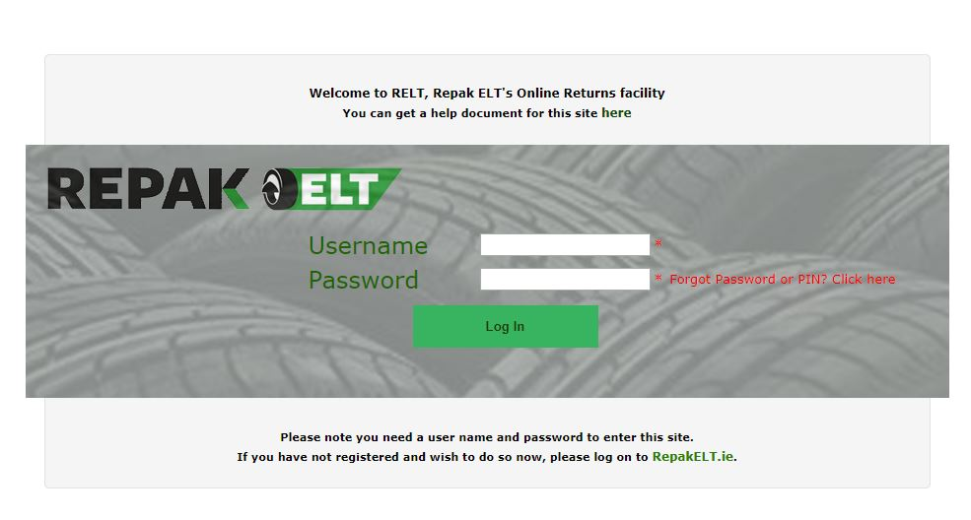

After clicking Forgot Password or PIN? Click here. The Password Reset page will open, entre in your Username and then click Continue on the bottom right hand side.

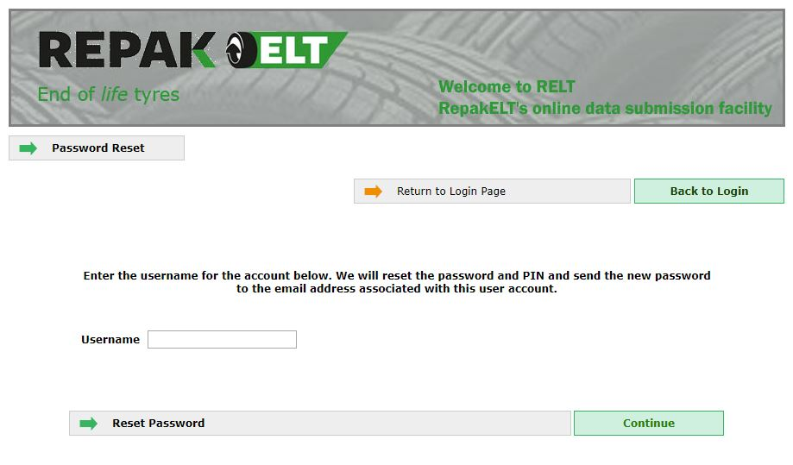

The below message will appear.
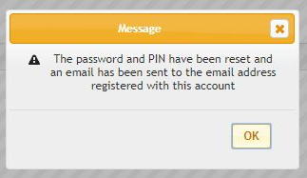

The following is an example of the message sent to member’s main contact email address:
The password for your CircolELT account has been reset.
The new password is wx1AzWLNcRc*pK
You can now login to the CircolELT site by clicking here
If you have any trouble logging in with this new password, please telephone the Circol ELT team on (01) 4618 600 or email us at info@Circolelt.ie

If you are not the main contact make sure you can access that email account before resetting. If you require the main contact email to be changed please contact Circol ELT. The new password is provided in the email and can be changed see page 5.
Click on the link ‘You can now login to the CircolELT site by clicking here’. This will bring you back to the Login page. Entre your Username and new Password. When the Password is reset this will automatically reset the PIN. Please follow the instruction from page 5 for re-entering PIN code.

